**Title: Brain Tumor Segmentation and Area Calculation from MRI Image Using Image Processing in SCILAB**.

**Abstract: The** project title Brain Tumor MRI Image Segmentation and Detection using image Processing is designed to detect and visualize the finer details about the brain tissues. To detect whether a tumor is developed over it.By detecting the tumor size, the stage of tumor can be determined for Benign (non- cancerous) and Malignant (cancerous) tumor. This project is divided in three different areas of operation namely: Pre-processing, Segmentation, Tumor Extraction and Area calculation. Pre-processing part comprises of noise removal and RGB to Gray conversion. The segmentation technique used in this project is K-means Clustering. The extraction part comprises of morphological operations, which uses Opening operation. At the end of operation the area of extracted tumor part is calculated.

**Keywords:** MRI image, Median filter, K-mean clustered, & Morphological Operation.

**Block Diagram:**

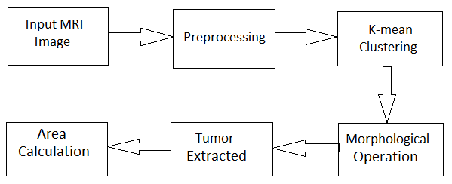

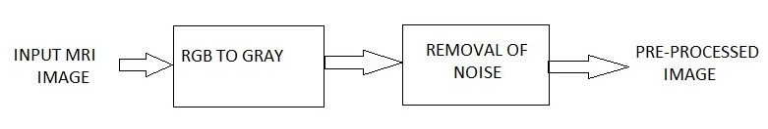

Fig: Pre-Processing Block.

**Results:**

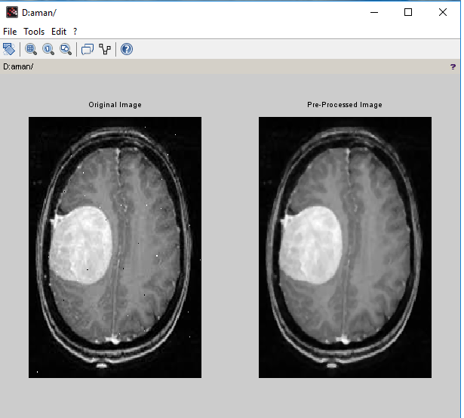

Fig: Pre-Processing of image.

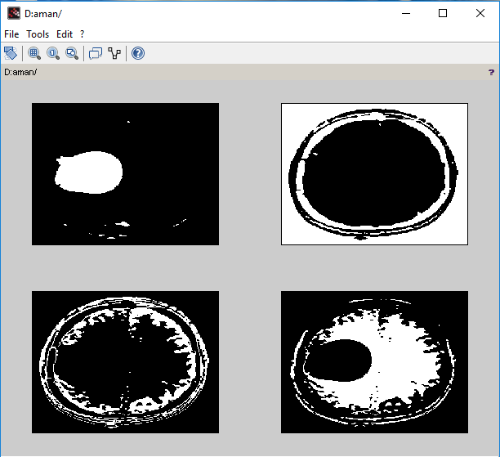

Fig: Clusters of Image.

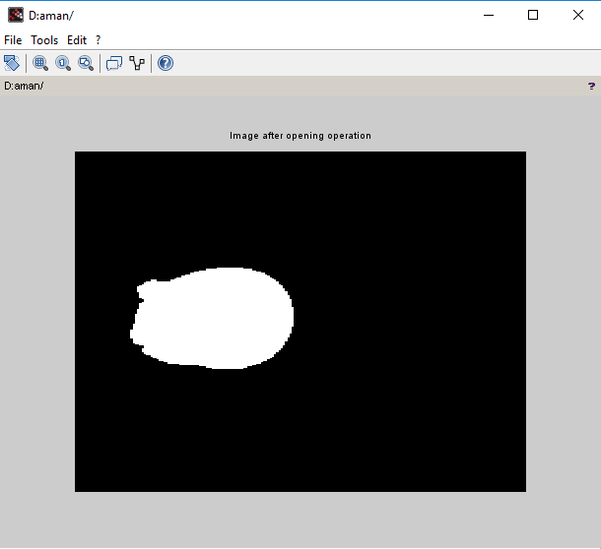

Fig: Extracted Tumor Part.

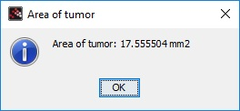

Fig:- Area of Extracted Tumor.